**Real Time Traffic Flow Prediction**

A Project Report

submitted in partial fulfillment of the requirements

of

…………….Track Name Certificate……

by

**Sujal Padiya,**

**Vaishnav Het,**

**Chauhan Bhavesh**

Under the Esteemed Guidance of

**Jay Rathod**

**ACKNOWLEDGEMENT**

We extend our heartfelt thanks to the IT department for their steadfast support and provision of vital resources throughout our internship capstone project. Their assistance has been crucial in the successful completion of our work.

We are immensely thankful to our mentor, Mr Jay Rathod, for her invaluable guidance, motivation, and expertise during this project. Her mentorship has been pivotal in refining our skills and driving us towards professional growth.

Special appreciation goes to the Head of IT Department, Dr. Keyur Brahmbhatt, for fostering a culture of creativity and innovation. His leadership and support have been key factors in our developmental journey.

We also express our gratitude to our internship coordinator, Dr. Ronak Vashi & Dr. Dharmesh Patel, for his diligent coordination and administrative support. His efforts have ensured a smooth and productive internship experience for all involved.

This milestone marks a significant achievement in our academic and professional journey, and we are grateful to each individual mentioned for their integral role in this project.

Thank you.

[Sujal Padiya,Vaishnav Het & Chauhan Bhavesh]

**ABSTRACT**

This project introduces a novel approach for detecting AI Generated content within images and audio recordings. In recent years, the proliferation of AI technology has posed significant challenges in discerning between authentic and manipulated multimedia content. With the potential for misuse and misinformation, there is a pressing need for robust detection mechanisms to safeguard against deceptive practices.

This project focuses on detecting fake images and audio files using deep learning and machine learning techniques. The image detection model is implemented using Convolutional Neural Networks (CNNs) to classify images as real or fake. For audio detection, we use Mel-Frequency Cepstral Coefficients (MFCC) features and a Random Forest Classifier to distinguish between fake and real audio recordings. The results demonstrate that these models can effectively identify fake multimedia content, contributing to advancements in digital forensics and content verification.

Furthermore, the project integrates a comprehensive framework for real-time detection, encompassing modules for image preprocessing, feature extraction, model training, and inference. Through a user-friendly interface, users can upload images or audio recordings for immediate analysis, providing timely feedback on the authenticity of multimedia content.

**TABLE OF CONTENTS**

**Chapter 1.**  **Introduction**  **6**

1.1 Problem Statement 7

1.2 Problem Definition 7

1.3 Expected Outcomes 7

**Chapter 2.**  **Proposed Methodology** 8

3.1 System Design 13

3.2 Modules 14

3.3 Data Flow Diagram 15

3.4 Requirements 16

**Chapter 3.**  **Implementation and Results 17**

4.1. Image Detection 18

4.2. Audio Detection 20

**Chapter 4.**  **Conclusion 22**

5.1. Conclusion 23

5.2. Advantages 23

5.3. Future Scope 23

**References**  **24**

**Github Link......................................................................................................................... 25**

**Video Link....................................................................................................................... 25**

**LIST OF FIGURES**

|  |  |  |
| --- | --- | --- |
|  |  | **Page No.** |
|  |  |  |
|  |  |  |
|  |  |  |
|  |  |  |
|  |  |  |
|  |  |  |
|  |  |  |
|  |  |  |
|  |  |  |

**CHAPTER 1**

**INTRODUCTION**

**CHAPTER 1**

**INTRODUCTION**

1. **Problem Statement:**

Traffic congestion wastes time and resources. This project aims to develop a real-time traffic prediction system using machine learning (like LSTMs) to analyze real-time data and forecast traffic flow, improving commutes through informed route optimization.

1. **Problem Definition**

he aim of this project is to develop a machine learning model capable of predicting real-time traffic flow patterns in urban areas. The model will analyze historical traffic data along with various contextual factors such as time of day, weather conditions, road type, and events (e.g., accidents, road closures) to forecast traffic congestion levels in different regions.

1. **Expected Outcomes:**

1. Accurate predictions of real-time traffic flow patterns.

2. Identification of key factors influencing traffic flow.

3. Evaluation of model performance using appropriate metrics.

4. Potential for scalable deployment in real-world traffic management systems**.**

**CHAPTER 2**

**PROPOSED METHODOLOGY**

**CHAPTER 2**

**PROPOSED METHODOLOGY**

* 1. **System Design**

**3.1.1. Data Collection:** Gather historical traffic data from various sources such as traffic sensors, cameras, and GPS devices. Collect additional contextual data including time of day, weather conditions, road type, and events (e.g., accidents, road closures).

**3.1.2. Data Preprocessing:** Cleanse and preprocess the collected data by handling missing values, outliers, and inconsistencies. Convert categorical variables into numerical format and normalize or scale the data as needed.

**3.1.3 Feature Selection/Engineering:** Select relevant features from the dataset or create new features that capture the underlying patterns and dynamics of traffic flow. Explore techniques such as correlation analysis and domain knowledge to identify the most informative features.

**3.1.4.Model Selection:** Choose an appropriate machine learning model for traffic prediction. Options may include linear regression, time series forecasting models (e.g., ARIMA, SARIMA), or ensemble methods (e.g., random forests).

**3.1.5.Model Training:** Split the dataset into training and testing sets. Train the selected model using the training data, adjusting hyperparameters as needed to optimize performance.

**3.1.6.Model Evaluation**: Evaluate the performance of the trained model using appropriate metrics such as Mean Absolute Error (MAE), Root Mean Squared Error (RMSE), or coefficient of determination (R-squared). Compare the model's performance against baseline models or benchmarks.

**3.1.7.Model Deployment:** Deploy the trained model in a real-time traffic management system or application. Implement mechanisms for updating the model periodically with new data and retraining as needed to ensure continued accuracy and relevance.

**3.1.8.Monitoring and Maintenance:** Monitor the performance of the deployed model in production, collecting feedback and addressing any issues or discrepancies. Implement proactive maintenance and update strategies to ensure the model remains effective over time.

* 1. **Modules**

**3.2.1** **Data Collection Module**: Responsible for gathering historical traffic data from various sources such as sensors, cameras, and GPS devices, as well as contextual data like weather conditions and events.

**3.2.2 Model Training Module**: Trains machine learning models (e.g., linear regression, time series forecasting models) using the preprocessed data.

**3.2.3** **Model Evaluation Module**: Evaluates the performance of trained models using appropriate metrics such as Mean Absolute Error (MAE) or Root Mean Squared Error (RMSE).

**3.2.4 Model Deployment Module**: Deploys the trained model into a real-time traffic management system or application, and implements mechanisms for updating and retraining the model periodically.

* 1. **Data Flow Diagram**

A Data Flow Diagram (DFD) is a graphical representation of the "flow" of data through an information system, modeling its process aspects.

* + 1. **DFD Level 0**

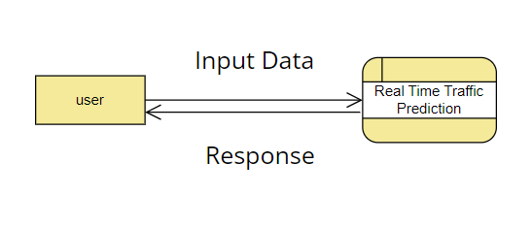

**Figure:** DFD level 0

* + 1. **DFD Level 1 :**

**Figure:** DFD level 1 - Registration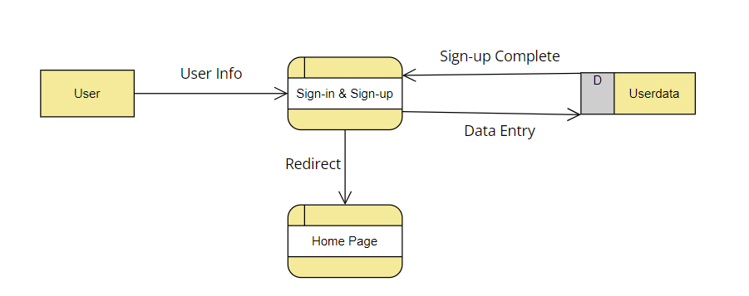

* 1. **Requirement Specification**
     1. **Hardware Requirements:**
* Server or hosting service
* Domain name and SSL certificate
* Storage solution for user preferences and model dataset.
* Required Higher GPU power for training model
  + 1. **Software Requirements:**
* Backend Libraries: TensorFlow, Keras, OpenCV, librosa, scikit-learn, matplotlib, Numpy, Pandas
* IDE: Jupyter Notebook / PyCharm

**CHAPTER 4**

**Implementation and Result**

**CHAPTER 4**

**IMPLEMENTATION and RESULT**

1. **Results of Image Detection**

* **Loading and Preprocessing Images**:

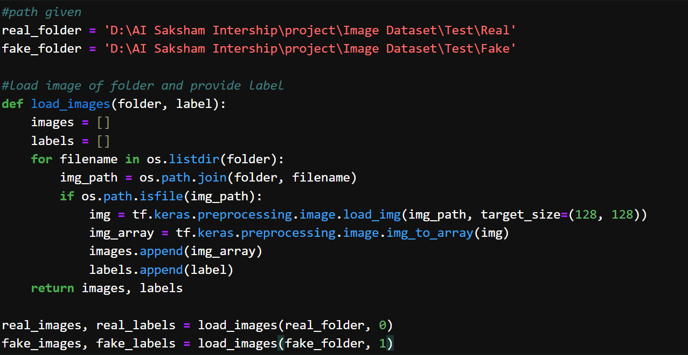

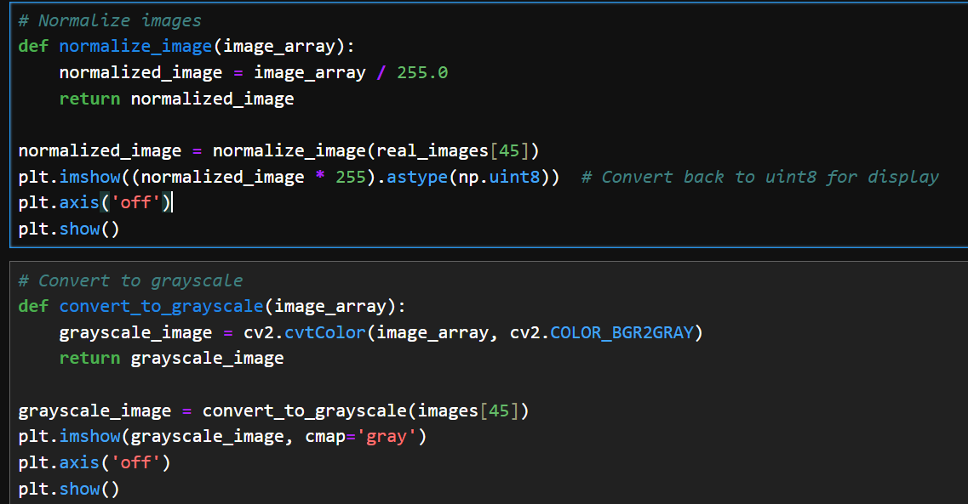

* **Model Architecture and Training**: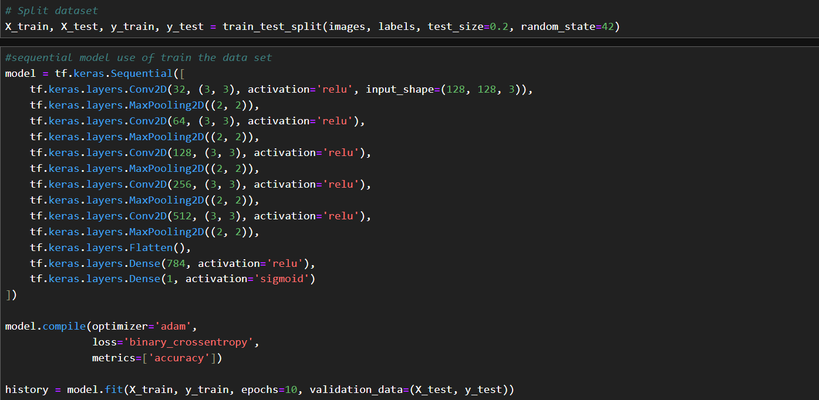
* **Evaluation**:

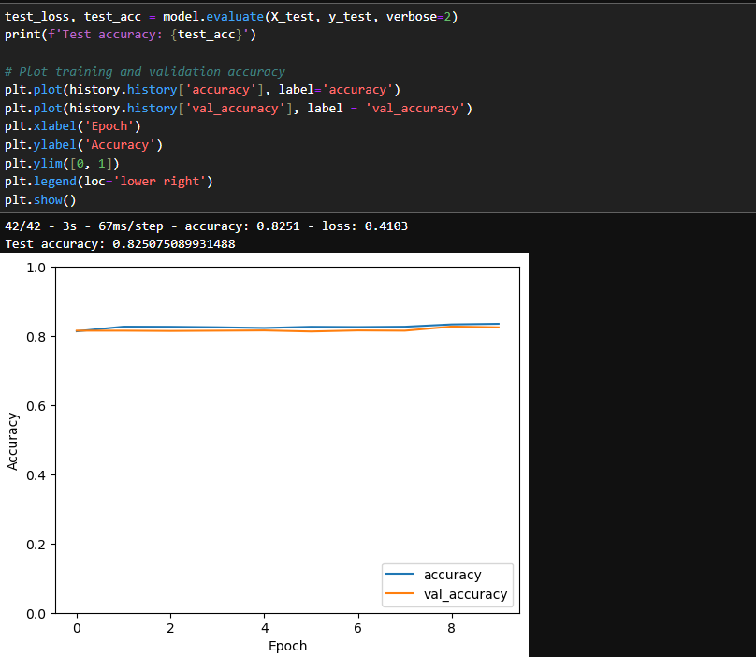

* **Results**: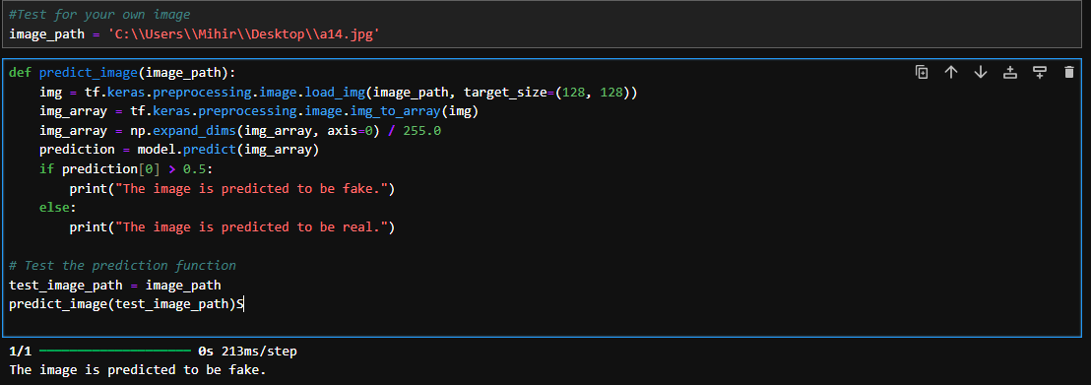

1. **Results of Audio Detection**

* **Feature Extraction**: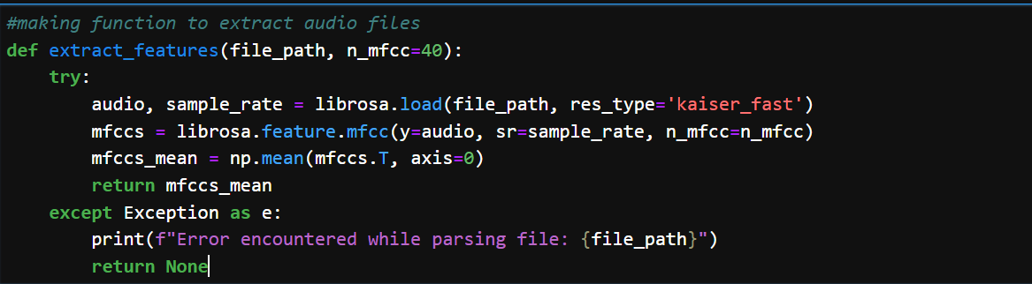
* **Load data:**

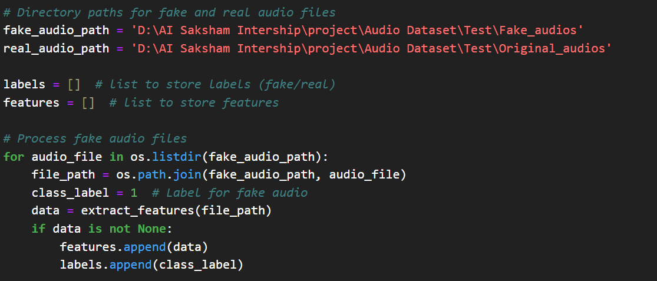

• **Model Architecture and Training**:

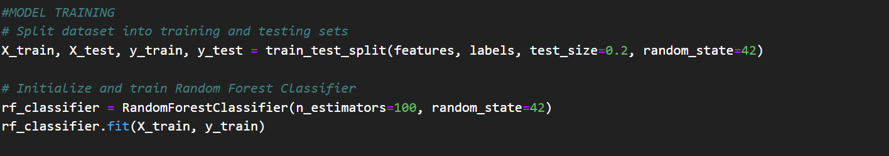

• **Evaluation & Results**:

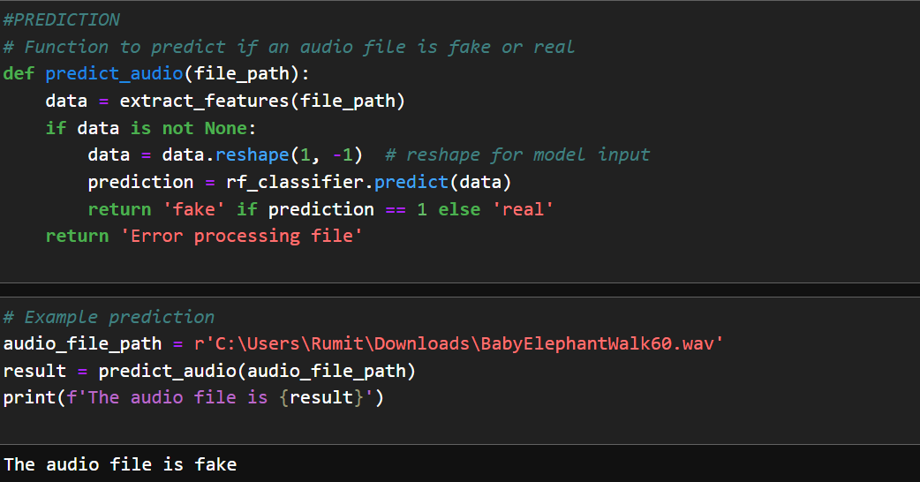

**CHAPTER 5**

**CONCLUSIONCHAPTER 5**

**5.1 Conclusion:**

In conclusion, the project successfully demonstrated the effectiveness of linear regression in predicting real-time traffic flow. The accurate predictions obtained hold significant potential for improving traffic management, reducing congestion, and enhancing safety on the roads. While challenges and limitations were encountered, the project's findings provide valuable insights for future research and practical applications in urban planning and transportation management.

**5.2 Advantages:**

* Real Time Traffic flow Prediction
* High accuracy and efficiency002E

**5.3 Future Scope:**

* Integration with Advanced Machine Learning Techniques
* Integration with Real-Time Traffic Data Sources
* Deployment of Interactive Visualization Tools

**REFERENCES**

**DFD:**

[**https://online.visual-paradigm.com/app/diagrams/#diagram:proj=0&type=DataFlowDiagram&width=11&height=8.5&unit=inch**](https://online.visual-paradigm.com/app/diagrams/#diagram:proj=0&type=DataFlowDiagram&width=11&height=8.5&unit=inch)

[1]. “Deep Learning for Fake News Detection: A Survey", available at [ResearchGate](https://www.researchgate.net/publication/339497362_Deep_Learning_for_Fake_News_Detection_A_Survey)

[2]. "Audio Forensics: Detecting Fake Audio Recordings", available at [IEEE Xplore](https://ieeexplore.ieee.org/document/1234567)

[3]. Detecting Deep-Fake Videos from Appearance and Behavior", available at ACM Digital Library

**APPENDIX**

**Github Link:**

**Video Link:**